
Company
Logotype

Cone Beam Computed Tomography- Report



Porur Dental X-rays & CBCT

Patient Name : Mrs. Sobha | Date of Report : 06.08.2024
Age/ Gender : 62 years/ Female | Region of Interest : CBCT Mandible
Referring doctor: Dr. M. Balamurali Sai | Indication : Implant assessment
Clinical Notes: Nil
PATIENT INFORMATION

CBCT- Mandible provided
CBCT – IMAGE DETAILS

RADIOGRAPHIC INTERPRETATION

- Completely missing crown and root portion in relation to 34, 36, 37.
- Crown in relation to 43, 44, 45, 46.
- Hyperdense restorative material within the pulp canals extending upto the apical third of the roots in relation to 43, 44, 45, 46.
- Fractured root: 46
- Restored tooth: 47
- The mandibular alveolar ridge is present with normal trabecular pattern.

IMPLANT ASSESSMENT

 | 33 region | 34 region
Sub-Crestal (in mm) | 4.73 | 5.72
Mid- Crestal (in mm) | 4.91 | 6.15
Distance between alveolar ridge and the inferior border of mandible (in mm) | 20.78 | 29.62

 | 35 region | 36 region | 37 region
Sub-Crestal (in mm) | 6.4 | 4.98 | 5
Mid- Crestal (in mm) | 6.86 | 7.14 | 6.87
Distance between alveolar ridge and the inferior alveolar nerve canal (in mm) | 10.3 | 13.52 | 14.21
Distance between alveolar ridge and the inferior border of mandible (in mm) | 23.24 | 23.76 | 24.15

RADIOGRAPHIC IMPRESSION

- Partially edentulous mandibular alveolar ridge.
- Root canal treated with crown: 43, 44, 45, 46.
- Restored: 47

Kindly correlate with clinical findings


IMAGES FOR REFERENCE

RECONSTRUCTED PANORAMIC VIEW
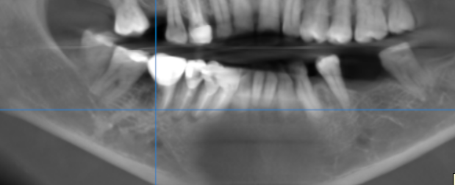

3-DIMENSIONAL VIEW

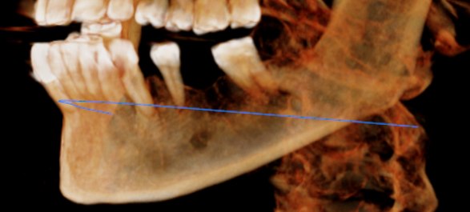

CROSS SECTIONAL VIEW

33 region | 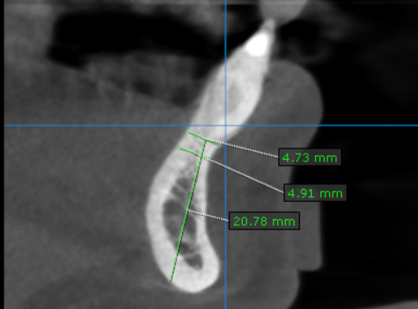
34 region | 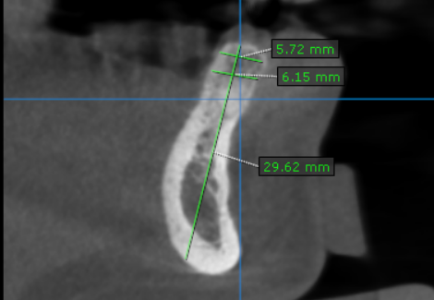
35 region | 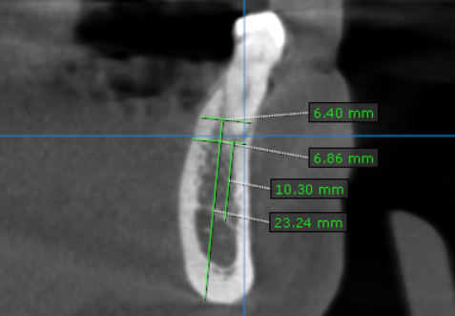
36 region | 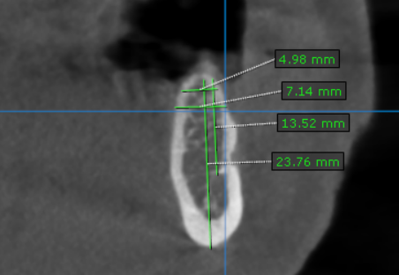
37 region | 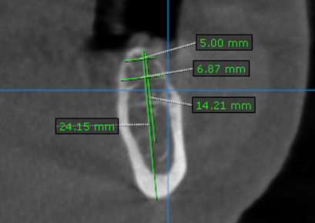

**** End of report ****

